**Data Structure Assignment 5**

Deadline: May 15, 23:55pm

1.

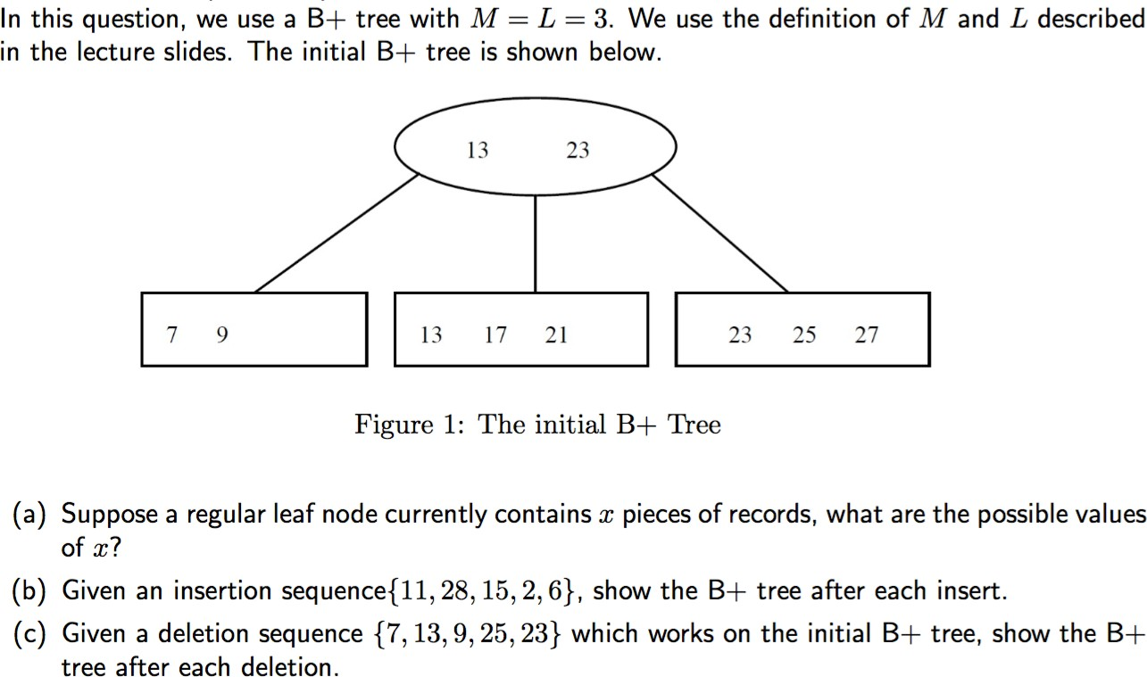

A）2 or 3

B）

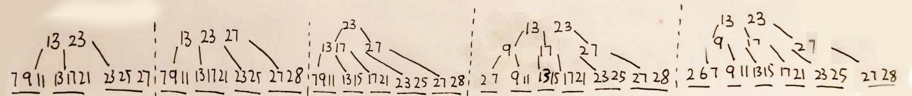

C）

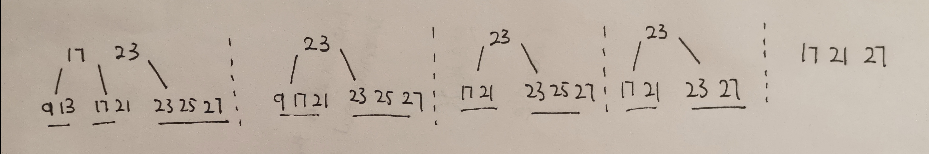

2. Given the graph used in class (see below), implement the BFS and DFS algorithm, output the path from source vertex (v2) to any provided target vertex.

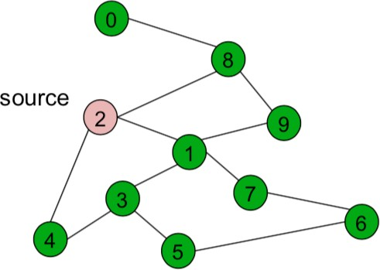

Details:

1. You need to save the graph with adjacency list. Hint: you may use following C++ standard library “list”, “vector”, “queue”. Usage of above libraries can be easily found in Google or Baidu.
2. Source vertex is fixed as v2, while target vertex is a variable. Your program needs to print out the path from source vertex to any provided target vertex variable. For example, if the target vertex variable is v7, in BFS, your program needs to print “2,1,7”; in DFS, need to print “2,8,9,1,3,5,6,7”.
3. You need to submit the cpp file which is executable. Grading of this question depends on the output result.
4. Zip the cpp file with the solution of Question 1, and submit to iSpace.